IS 119 Name _______________________________
Class __________ Date ________________________________
Reflections
Graph the image of the figure using the transformation given.
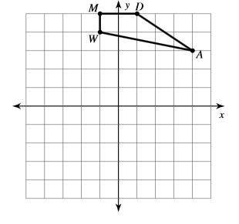
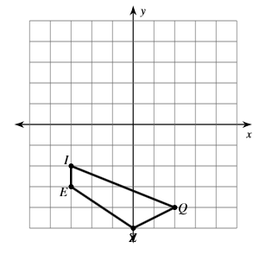
- Reflection across the x-axis. 2) Reflection across the x-axis.

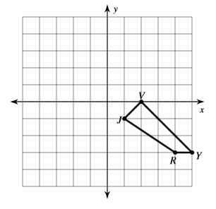
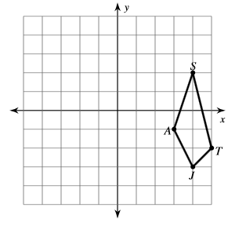
3) Reflection across the y-axis. 4) Reflection across the y-axis.

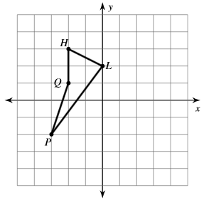
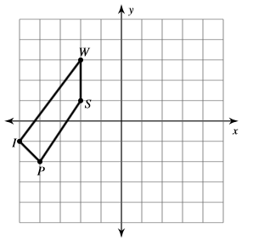
5) Reflection across the y-axis. 6) Reflection across the y-axis.

