Name _______________________________________ Class _________ Date ____________________
TRANSLATIONS HOMEWORK
Graph the image of the figure using the given rule.
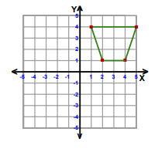
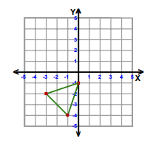
1. Translate 4 up. 2. Translate 4 left and 3 down.

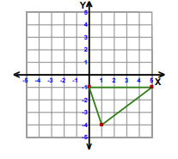
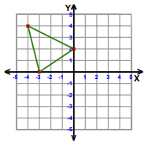
3. Translation: (x – 5, y + 3) 4. Translation: (x + 5, y – 5)

5. Write a rule to describe each transformation.
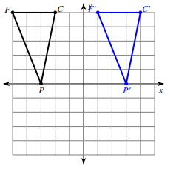
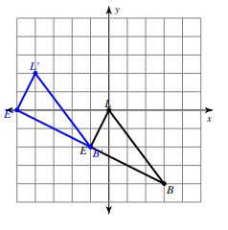

________________________________ _______________________________

6. Find the coordinates of the vertices of each figure after the given transformation.
Translation 2 units left and 1 unit down Q(0, -1), D(-2, 2), V(2, 4), J(3, 0)
Q’ __________ D’ __________ V’ __________ J’ __________

Translation (x + 3, y + 4) Z(-4, -3), I(-2, -2), V(-2, -4)
Z’ __________ I’ __________ V’ __________

