IS 119 Name ___________________

Class __________ Date ____________________

Dilations Homework

2) Graph the polygon with vertices: Q(4, 2), R(-4, 6), S(-6, -8), T(6, -10). . Using the origin as the center, dilate with a scale factor of $\frac{1}{2}$. List the coordinates of the final image. Q’ _____ R’ _____ S’ _____ T’ _____

1. 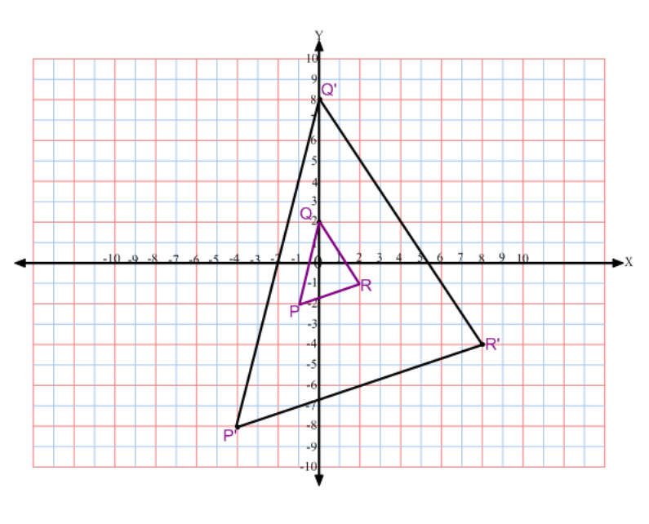What scale factor was applied to

transform triangle PQR into triangle P’Q’R’?



3) The original coordinates of a figure are (1,2), (-3,2), (8,0), (0,-8). After a dilation, the new coordinates are (5,10), (-15,10), (40,0), (0,-40). What was the scale factor used for this dilation?

4) A logo is 16 centimeters wide. If the logo is to be dilated by a factor of $\frac{7}{4}$, find the width of the logo. Show your work.