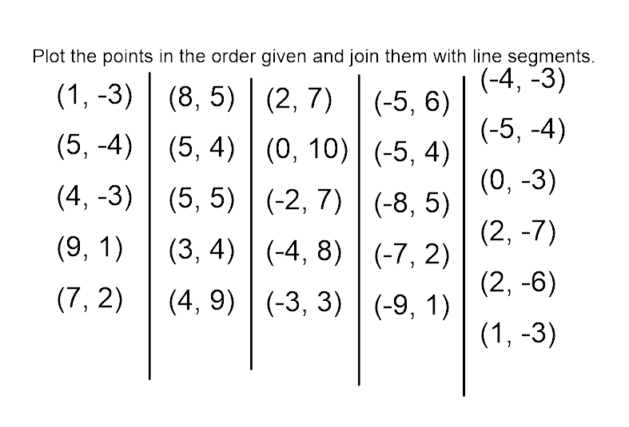
Coordinates to plot Maple Leaf

